QUIZ

MANAGEMENT

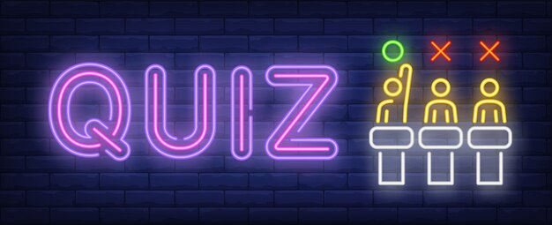

# AIM:

To prepare a quiz management system using python in which a quiz consisting few multiple choice questions is given to the user and the answer given by them is evaluated.

Code :

print("QUIZ ON CITIES OF INDIA")

Name = input("Enter your name:")

a1 = input("1. How many states and union territories are present in India currently? \n(a) 28 and 6 respectively \n(b) 29 and 7 respectively \n(c) 28 and 9 respectively \n")

a2 = input("2. Which Indian city is a capital of two states? \n(a) Hyderabad \n(b) Mumbai \n(c) Chandigarh \n")

a3 = input("3. Which is the smallest state in India in terms of area? \n(a) Tamilnadu \n(b) Goa \n(c) Kerala \n")

a4 = input("4. Which of the following is not a metropolitan city of India \n(a) Trivandrum \n(b) Mumbai \n(c) Chennai \n")

a5 = input("5. In which town of Nagaland was the world war 2 fought? \n(a) kohima \n(b) Dimapur \n(c) Phek \n")

given_answer = [a1,a2,a3,a4,a5]

correct_answer= {a1:"c", a2:"c", a3:"b", a4:"a", a5:"a"}

score=0

if given_answer[0] == correct_answer[a1]:

    score += 1

if given_answer[1] == correct_answer[a2]:

    score += 1

if given_answer[2] == correct_answer[a3]:

    score += 1

if given_answer[3] == correct_answer[a4]:

    score += 1

if given_answer[4] == correct_answer[a5]:

    score += 1

print (Name + " has scored",score)

output :

Trial Run 1 :

QUIZ ON CITIES OF INDIA

Enter your name: Anya

1. How many states and union territories are present in India currently?

(a) 28 and 6 respectively

(b) 29 and 7 respectively

(c) 28 and 9 respectively

c

2. Which Indian city is a capital of two states?

(a) Hyderabad

(b) Mumbai

(c) Chandigarh

c

3. Which is the smallest state in India in terms of area?

(a) Tamilnadu

(b) Goa

(c) Kerala

b

4. Which of the following is not a metropolitan city of India

(a) Trivandrum

(b) Mumbai

(c) Chennai

a

5. In which town of Nagaland was the world war 2 fought?

(a) kohima

(b) Dimapur

(c) Phek

a

Anya has scored 5

Trial Run 2:

QUIZ ON CITIES OF INDIA

Enter your name: Asha

1. How many states and union territories are present in India currently?

(a) 28 and 6 respectively

(b) 29 and 7 respectively

(c) 28 and 9 respectively

a

2. Which Indian city is a capital of two states?

(a) Hyderabad

(b) Mumbai

(c) Chandigarh

c

3. Which is the smallest state in India in terms of area?

(a) Tamilnadu

(b) Goa

(c) Kerala

b

4. Which of the following is not a metropolitan city of India

(a) Trivandrum

(b) Mumbai

(c) Chennai

b

5. In which town of Nagaland was the world war 2 fought?

(a) kohima

(b) Dimapur

(c) Phek

a

Asha has scored 3